00c - Sprint Plan - Sprint 1

Part 1: Sprint Info & Task Management board

Team number: 12
Sprint Number: 1 | Sprint Duration (Start – End Dates): May 4 - May 8
Task Manager Platform Link here (Clickable and Public) :
https://trello.com/invite/b/69f1252414c3094e343d62fe/ATTI08c02146cbf06f985e835fed3d7d8b55340072F9/-
Task Coordinator name here :
Jonah Botelho

Part 2: Sprint Plan

Sprint Goal(s)

By the end of this sprint, we will have the UI for our app done and the main question flow completed and easy to follow.

Outcomes

Outcome | Answer to “So What?”
Conflict free and easy to follow UI is created | Users can complete the survey without getting confused
Question routing structure is fully defined and implemented | Users only see questions relevant to their injury
Users can complete the survey in a shorter time than the previous prototype. | Users can be more efficient and spend less time doing these questions

Deliverables

Deliverables | Show me
Completed wireframe on Figma | Figma screens for every page
Local HTML page for survey | Screenshots of page
Frontend source code | Source code folders

Tasks
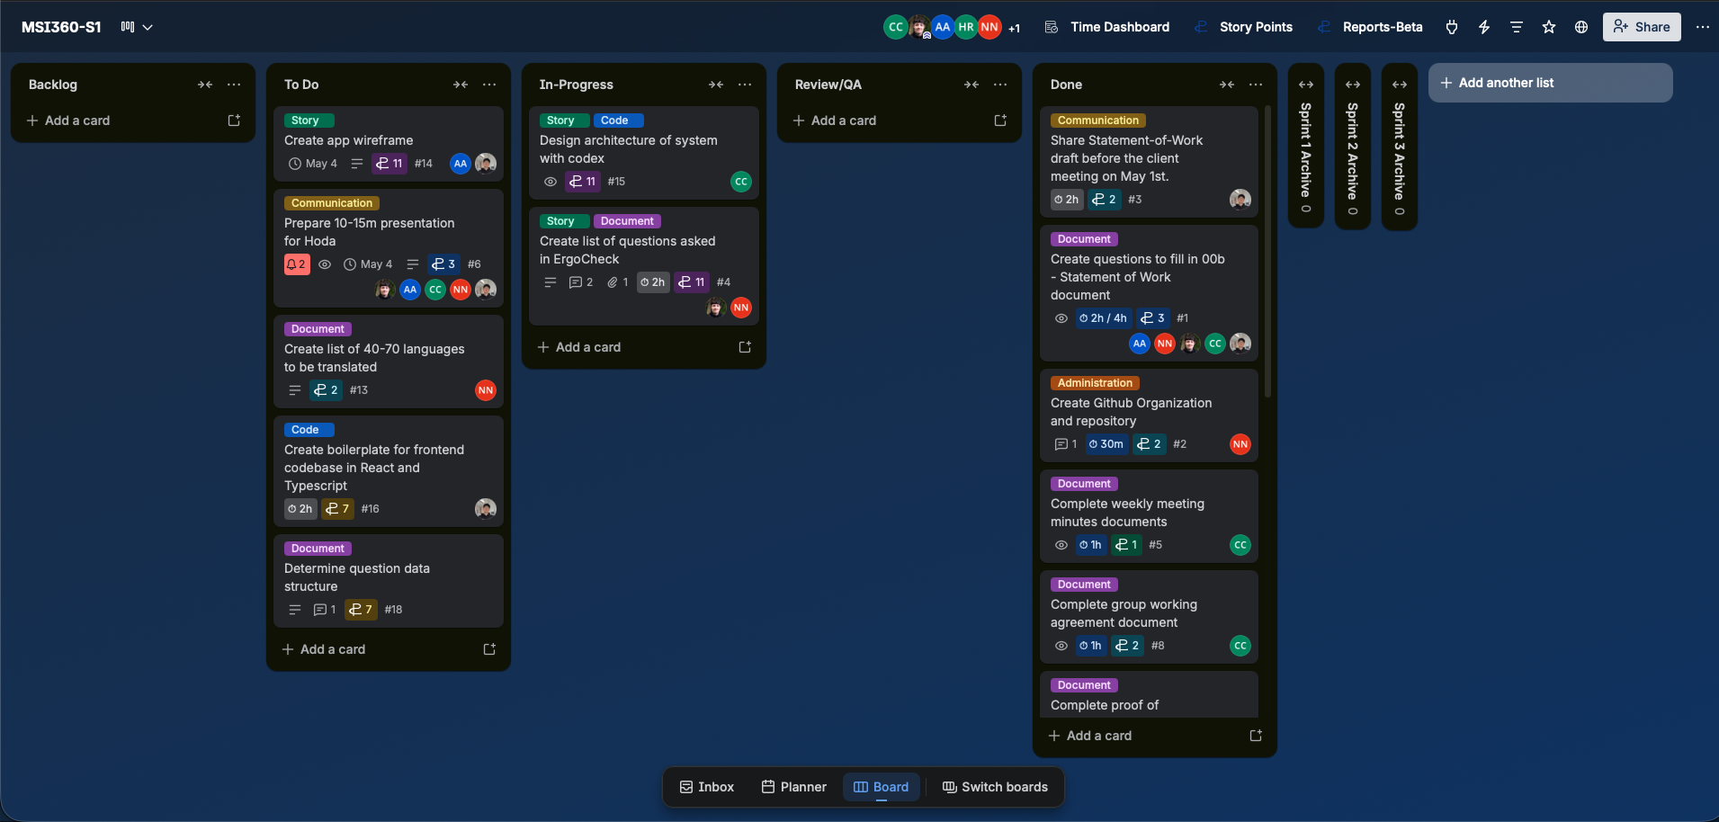

Risks and Issues
Risk ID + Related Task ID(s) | Risk or Issue Description | Potential Impact | Mitigation/Resolution Steps | Status

